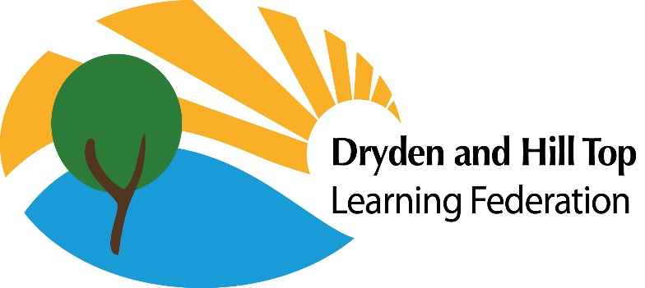
Dryden School
Tel: 0191 4203812
drydenschool@gateshead.gov.uk Head Teacher: Claire Lapworth

Hill Top School
Tel: 0191 4692462
hilltopschool@gateshead.gov.uk
Head Teacher: Anita Bell

Dear Parent/Carer,
Re: Changes to free school meal entitlement
If your child already receives benefit related Free School Meals, the FSM team at Gateshead Council will automatically review your eligibility over the summer - you do not need to take any action at this time.
However, it is very important that families who could qualify, apply for Targeted Free School Meals as soon as possible. (targeted eligibility continues to be based on the existing £7,400 threshold).
If you are in receipt of Universal Credit, you may be entitled to targeted free school meals. Even if you have not previously qualified for benefit related free school meals, you are strongly encouraged to apply or reapply, as many families will now be eligible, so please ensure you apply now. (expanded eligibility applies to meals only and covers those not entitled under the targeted criteria but who are in receipt of Universal Credit).
How to Apply
You can ONLY APPLY ONLINE USING THE FOLLOWING LINK:
- Online via the council website:
https://myservice.gateshead.gov.uk/housing-benefit-forms/apply-for-free-school-meals/
Applying is quick and could make a significant difference, so we strongly encourage all eligible families to check and apply.
If you have any questions or need support completing the form, please contact the school office 0191 4203812

